**BLOCKCHAIN AND CYBERSECURITY**

**PROBLEM STATEMENT**

**INTRODUCTION**

**Now a days the challenge of counterfeit drugs in the pharmaceutical industry has been increasing across the globe over the past many years**.

**As we know that most of the popular pharmacies provides the original medicines whereas many other pharmacies may contain counterfeit medicines, they even sell those counterfeit medicines to many people without knowing whether it is original or not. Because of this most of us are facing problems.**

**Medicine is the basic need for everyone in everyday use. In order to solve this problem, we came up with the solution.**

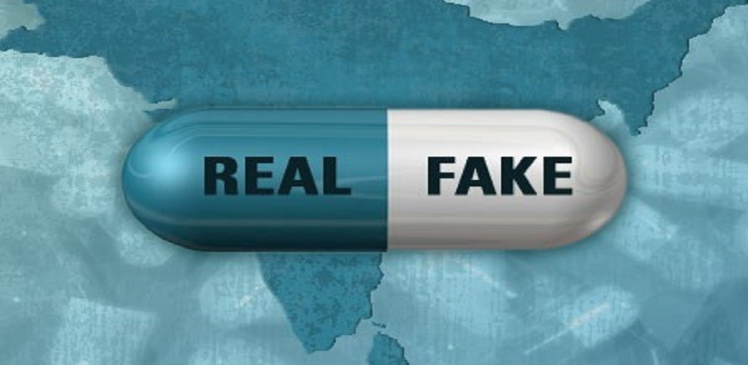

**SOLUTION**

**To detect the false medicine, we proposed a medicine tracing system using blockchain technology.**

**For this problem we have Batch number of medicines and License number of dealers.**

**If it does not match with the Batch number of medicines and License number of dealers which are present in smart contract then the medicine is false or fake and displays the info to the consumer.**

**If any License number does not match, we can detect the medicine is not original or fake.**

fabric Component

PEER

* Manufacturer
* Dealer
* Consumer

SMART CONTRACT

Pseudo code

// Create Batch number from manufacturer

Batch number=994;

Product id=142;

// Updating License number of Dealer

* Update Batch number by manufacturer

Update (‘Product id’, ‘Batch number’, ‘License number’)

Here we can know the License number of the Dealer which has manufacturer Batch number and Product id.

* Update and add License number to the record

Update (‘Product id’, ‘Batch number’, ‘License number’)

After getting the License number of the Dealer, we will add to the record.

Product id Batch number License

// verification

Taking information from consumer

Consumer enters Batch number, License number

if (consumer data==updated data)

legitimate

else

counterfeit

LEDGER

* We will have Batch numbers from manufacturer and License numbers of different dealers. We will also have the details of the medicines.

CHANNEL

It is the common connection for Manufacturer, Dealer and Consumer.

CERTIFICATE AUTHORITIES

X509 certificate:

**An X.509 certificate is a digital certificate based on the widely accepted**[**International Telecommunications Union (ITU) X.509 standard**](https://www.itu.int/rec/T-REC-X.509)**, which defines the format of public key infrastructure (PKI) certificates. They are used to manage identity and security in internet communications and computer networking. They are unobtrusive and ubiquitous, and we encounter them every day when using websites, mobile apps, online documents, and connected device**

**An X. 509 certificate is a digital certificate that uses the widely accepted international X. 509 public key infrastructure (PKI) standard to verify that a public key belongs to the user, computer or service identity contained within the certificate.**

HIGH LEVEL FLOW

 

